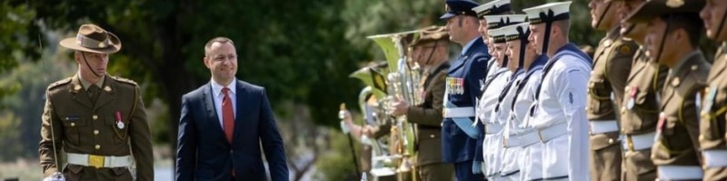
RUSIV Lunchtime Speaker – Thursday 24th April 2025,
1200 for 1230, Anzac House, 4 Collins St

HE Vasyl Myroshnychenko, Ambassador of Ukraine to Australia

TOPIC – The War in Ukraine – Three years on

His Excellency took up his position in Canberra in April 2022.. He is a Member of the Supervisory Board of the Ukrainian Institute in Kviv, a public institution affiliated with the Ministry of Foreign Affairs. Its mission is to strengthen Ukraine's international standing through the means of cultural diplomacy.
He has a MSc from the London School of Economics and a BA and MA from the National University of Kviv.
Mr Myroshnychenko has over 20 years’ experience in strategic communications and government relations, working with the Ukrainian government, NGOs and Ukrainian clients in Washington, London, Brussels, Frankfurt, Davos and the Gulf.
Mr Myroshnychenko was the co-founder of the news agency, Ukraine Crisis Media, and the CEO/Partner of CFC Big Ideas, an international communications consultancy. He has been a frequent foreign policy commentator and has often spoken on the topics of public diplomacy, national branding, lobbying and advocacy, international trade, propaganda and disinformation.

As usual, tea and coffee from 12 noon.. Entry fee of $10.

